CO1-AT2 – Agile Sprint Planning & User Story Workshop
Problem Statement: AI-Based Fashion Supply Chain Optimization Platform
NAME: D. Vyshali | SLOT: D
REGNO: 192411197 | COURSE CODE: CSA1007

Methodology: The Agile Scrum Approach
This sprint planning document applies Agile Scrum practices to the AI-Based Fashion Supply Chain Optimization Platform. Scrum was selected because the platform integrates several interdependent capabilities — demand forecasting, inventory allocation, supplier coordination, shipment tracking, trend monitoring, and reporting — that benefit from incremental delivery, continuous stakeholder feedback, and the flexibility to re-prioritize as fashion-market conditions change season to season.
The workshop follows the standard Scrum cadence shown below: the Product Backlog is refined and prioritized, a subset of items is pulled into Sprint Planning to form the Sprint Backlog, the team executes the sprint through Daily Scrums, and the sprint closes with a Review and Retrospective that feeds learning back into the backlog.
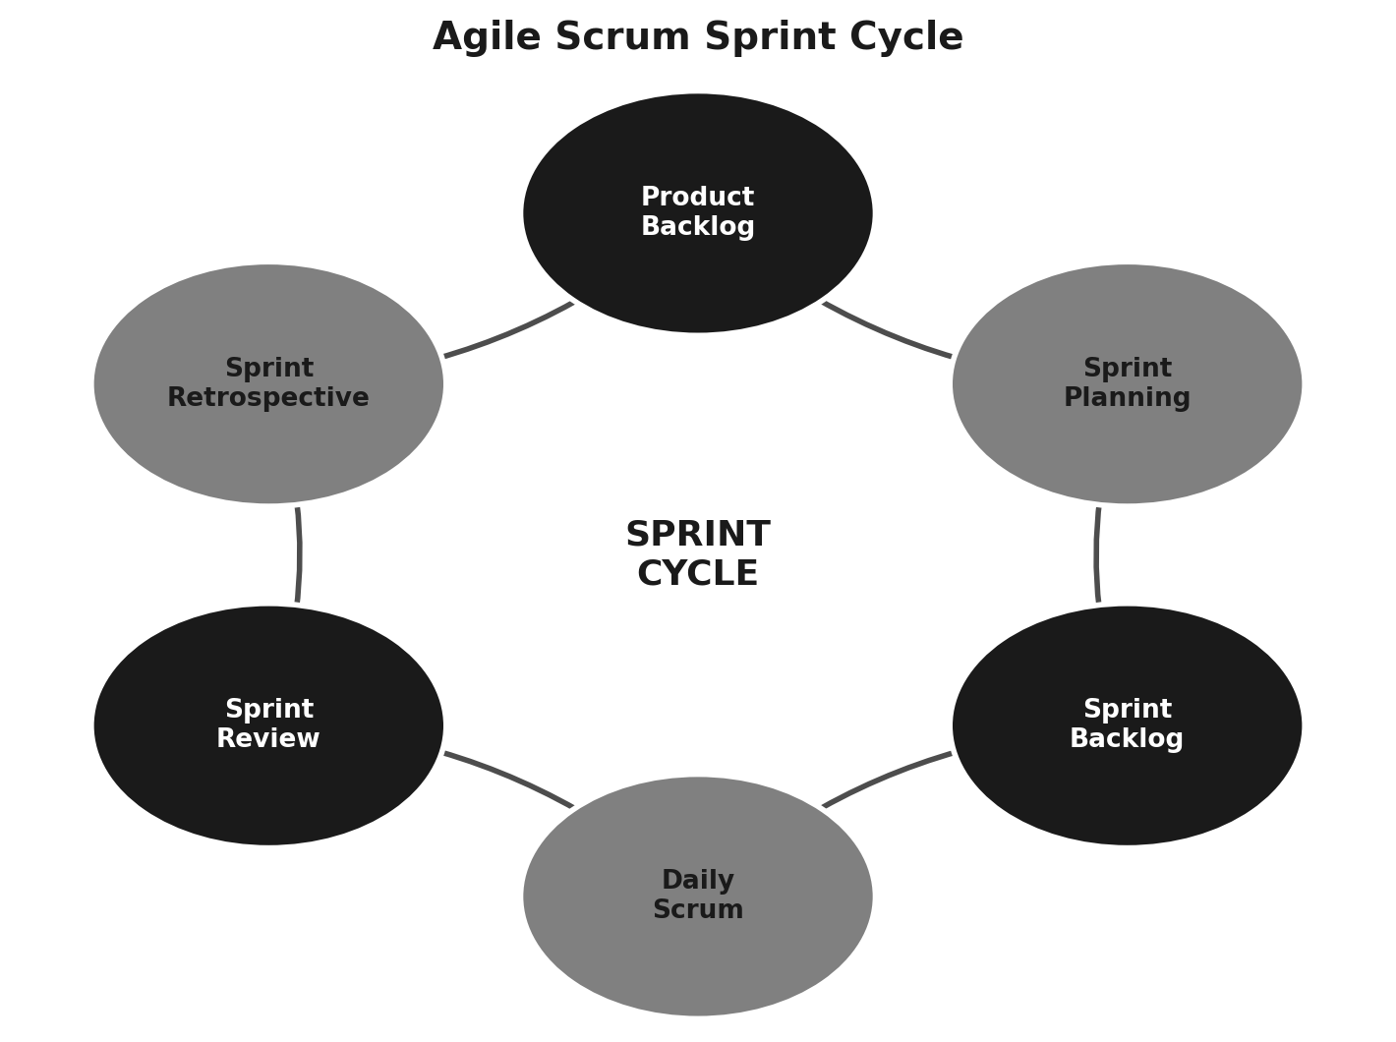
Figure 1: Agile Scrum sprint cycle followed for this workshop

1. Project Vision and Stakeholders

1.1 Project Vision
To build an AI-driven platform that gives fashion retailers end-to-end visibility and control over their supply chain — forecasting demand accurately, allocating inventory intelligently, coordinating suppliers efficiently, and tracking shipments in real time — so that stock shortages and excess inventory are minimised and profitability is improved.

1.2 Project Objectives
- Forecast product demand using historical sales, seasonality, and trend data.
- Optimize inventory allocation across warehouses and retail stores.
- Coordinate suppliers for timely, reliable replenishment.
- Track shipments in real time across the logistics network.
- Monitor sales trends to detect fast- and slow-moving products.
- Generate consolidated supply chain performance reports.

1.3 Key Stakeholders
The platform serves a cross-functional group of stakeholders, each with distinct goals and pain points that the product backlog must address:
Stakeholder | Role in the Project | Primary Interest
Business / Brand Executives | Set strategic direction; review supply-chain KPIs | Profitability and brand growth
Supply Chain Managers | Own inventory allocation and overall coordination | Balanced stock levels, fewer disruptions
Procurement & Sourcing Team | Manage supplier relationships and purchase orders | Reliable, cost-effective sourcing
Warehouse & Logistics Team | Receive, store, and dispatch inventory; track shipments | Accurate, real-time shipment visibility
Suppliers / Vendors | Fulfil purchase orders and share production status | Clear demand signals and lead times
Merchandising & Sales Team | Interpret sales trends; plan assortments and promotions | Early trend detection
Data Science / AI Team | Build and maintain forecasting and optimization models | Access to clean, timely data
IT Administrators | Maintain platform infrastructure, security, and integrations | System reliability and uptime
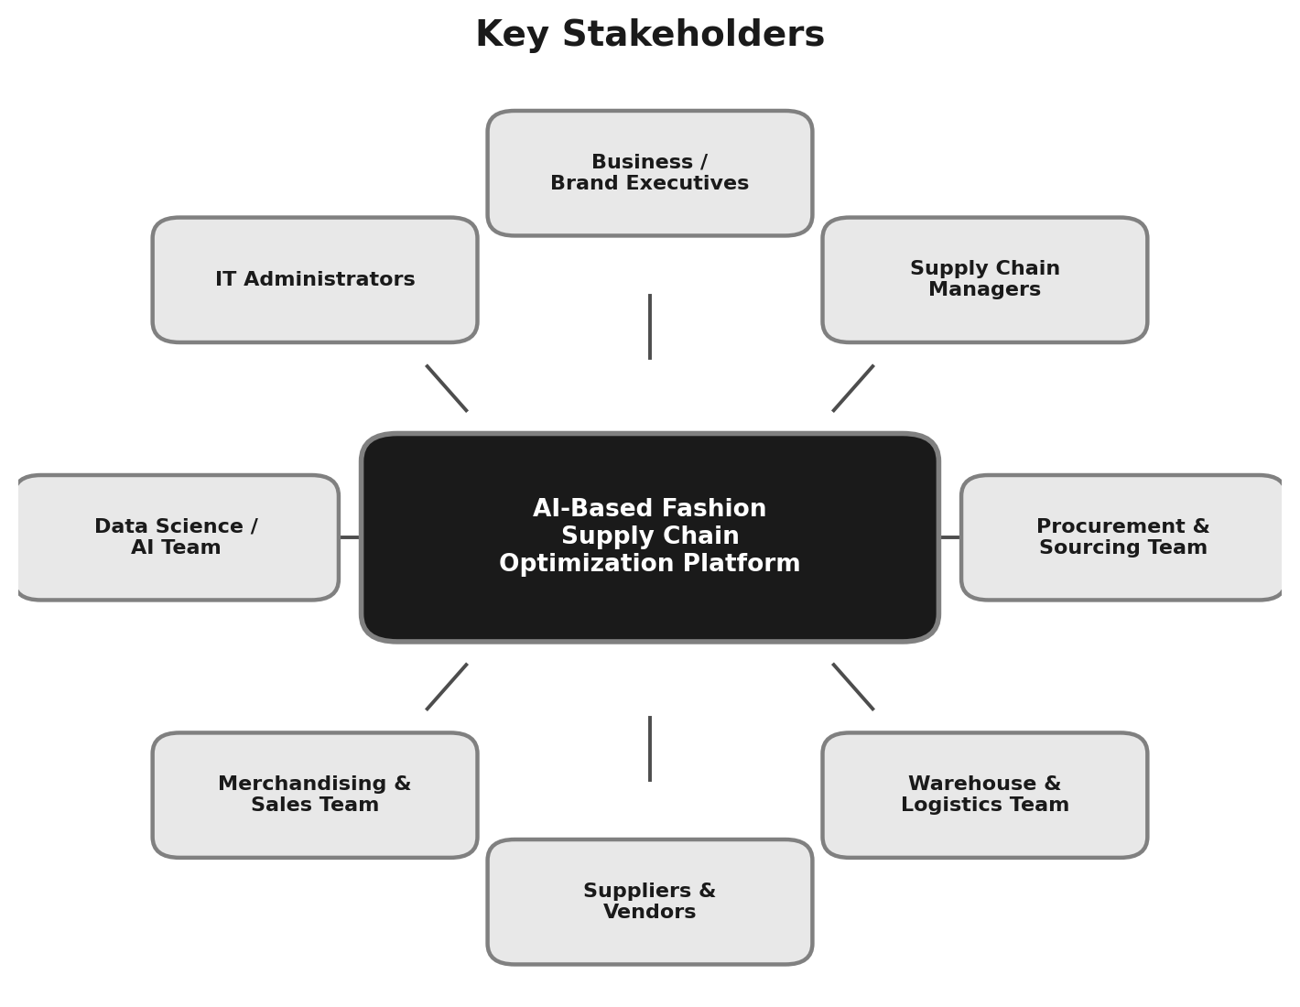
Figure 2: Stakeholder map for the AI-Based Fashion Supply Chain Optimization Platform

2. Epics and User Stories
The product requirements are grouped into six Epics that mirror the platform's end-to-end process flow: Demand Forecasting, Inventory Allocation, Supplier Coordination, Shipment Tracking, Sales Trend Monitoring, and Supply Chain Reporting. Each Epic is decomposed into User Stories following the standard Agile format: “As a <user>, I want <feature>, so that <benefit>.”
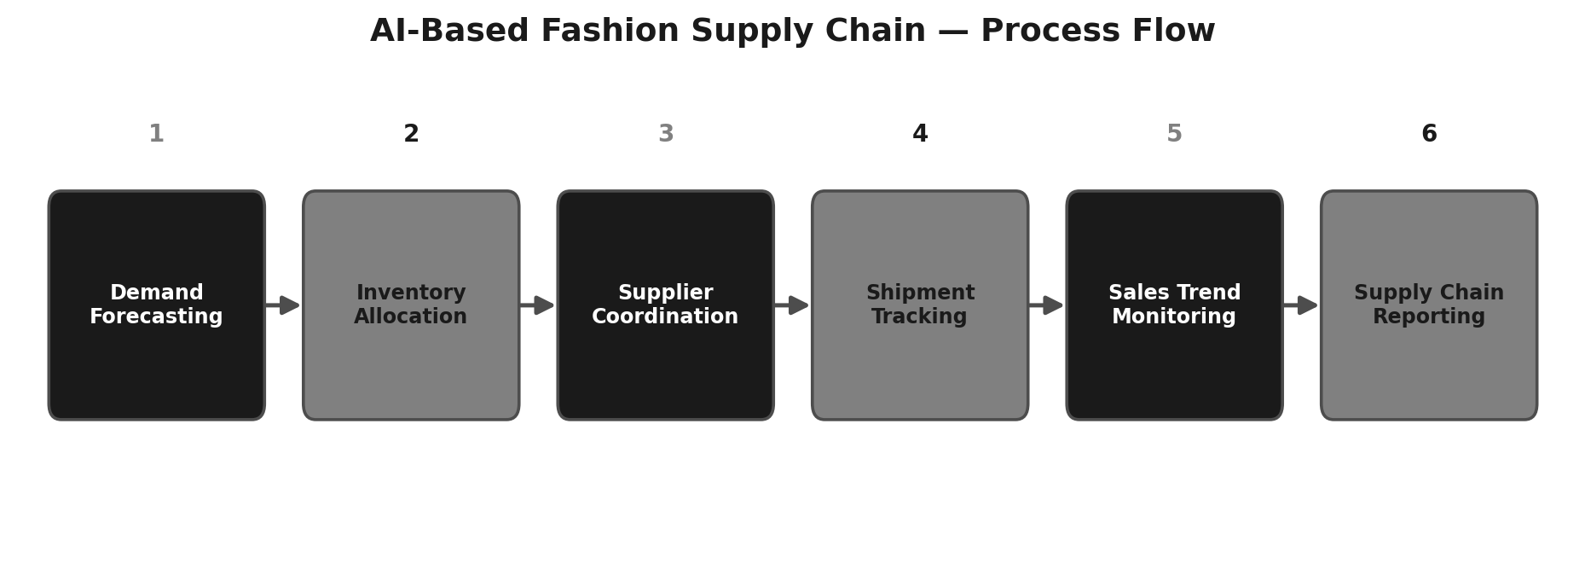
Figure 3: Process flow mapped to the six Epics

Epic 1 – Demand Forecasting
ID | User Story
US-1.1 | As a merchandising manager, I want the system to forecast product demand from historical sales and seasonal trend data, so that I can plan purchase orders accurately.
US-1.2 | As a supply chain manager, I want demand forecasts broken down by region and season, so that I can allocate inventory accordingly.

Epic 2 – Inventory Allocation Optimization
ID | User Story
US-2.1 | As a warehouse manager, I want the system to recommend optimal stock allocation across stores, so that inventory matches regional demand.
US-2.2 | As a supply chain manager, I want alerts for understocked or overstocked items, so that I can take corrective action quickly.

Epic 3 – Supplier Coordination
ID | User Story
US-3.1 | As a procurement manager, I want to view supplier performance metrics, so that I can select reliable partners.
US-3.2 | As a procurement officer, I want to send automated purchase orders to suppliers, so that replenishment cycles are faster.

Epic 4 – Shipment Tracking
ID | User Story
US-4.1 | As a logistics coordinator, I want to track shipments in real time, so that I can anticipate delays.
US-4.2 | As a warehouse manager, I want automated notifications when shipments arrive, so that I can plan receiving staff.

Epic 5 – Sales Trend Monitoring
ID | User Story
US-5.1 | As a merchandising analyst, I want to monitor real-time sales trends by category, so that I can identify fast-moving products.
US-5.2 | As a marketing manager, I want alerts on emerging fashion trends, so that I can plan promotional campaigns.

Epic 6 – Supply Chain Reporting
ID | User Story
US-6.1 | As a supply chain executive, I want automated supply chain performance reports, so that I can review KPIs regularly.
US-6.2 | As a business owner, I want a summary dashboard, so that I can make quick strategic decisions.

3. Acceptance Criteria
Acceptance criteria define the measurable conditions under which each user story is considered complete. The Given–When–Then format is used below for the highest-priority user story from each Epic.
Story | Given | When | Then
US-1.1 | the system has at least 12 months of historical sales data | a merchandising manager requests a demand forecast for a product | the system displays a forecast with a confidence interval for the next 4–12 weeks
US-2.1 | current stock levels and regional sales data are available | the allocation engine runs its recommendation cycle | it proposes a store-wise allocation plan that reduces projected stock-outs by a target threshold
US-3.2 | an approved purchase order exists in the system | the procurement officer confirms the order | the order is transmitted to the supplier automatically and a confirmation is logged
US-4.1 | a shipment has been dispatched with a tracking reference | its location status changes | the dashboard updates the shipment's status within 15 minutes
US-5.1 | point-of-sale data is streaming into the platform | sales of a category exceed the defined trend threshold | the system flags the category as “trending” and notifies the merchandising team
US-6.1 | a reporting period has ended | the scheduled report job runs | a supply chain performance report (KPIs, stock levels, supplier delays) is generated and emailed to executives

4. Product Backlog Prioritization
The backlog is prioritized using the MoSCoW technique (Must have, Should have, Could have, Won't have this sprint), weighed against business value and dependency on other stories. Forecasting and allocation stories are prioritized first because every downstream capability — supplier orders, shipments, and reporting — depends on accurate demand and stock data.
ID | User Story (Summary) | Priority | Business Value | Dependency
US-1.1 | Forecast demand from historical/seasonal data | Must | High | None (foundational)
US-2.1 | Recommend optimal stock allocation | Must | High | Depends on US-1.1
US-2.2 | Alert on under/overstocked items | Must | High | Depends on US-2.1
US-3.2 | Send automated purchase orders | Should | High | Depends on US-2.2
US-4.1 | Real-time shipment tracking | Should | Medium | Depends on US-3.2
US-1.2 | Forecasts by region and season | Should | Medium | Depends on US-1.1
US-3.1 | Supplier performance metrics | Could | Medium | Independent
US-5.1 | Monitor sales trends by category | Could | Medium | Independent
US-4.2 | Shipment-arrival notifications | Could | Low | Depends on US-4.1
US-6.1 | Automated performance reports | Won't (Sprint 1) | High | Depends on most modules

5. Sprint Backlog Planning — Sprint 1
Sprint 1 focuses on the “Must have” stories that establish the forecasting and allocation foundation, since every other Epic depends on this data. Each selected story is broken down into actionable development tasks.
User Story | Development Tasks | Owner
US-1.1 – Forecast demand | • Collect & clean historical sales data • Build baseline forecasting model • Expose forecast via API • Build forecast confidence-interval UI | Data Science / Backend
US-2.1 – Recommend stock allocation | • Design allocation optimization logic • Integrate forecast + current stock data • Build allocation recommendation UI | Backend / Frontend
US-2.2 – Stock level alerts | • Define under/overstock thresholds • Build alerting service • Build notification UI component | Backend / Frontend

6. Story Point Estimation
Story points were estimated using Planning Poker with the Fibonacci sequence, reflecting relative effort, complexity, and uncertainty rather than absolute time.
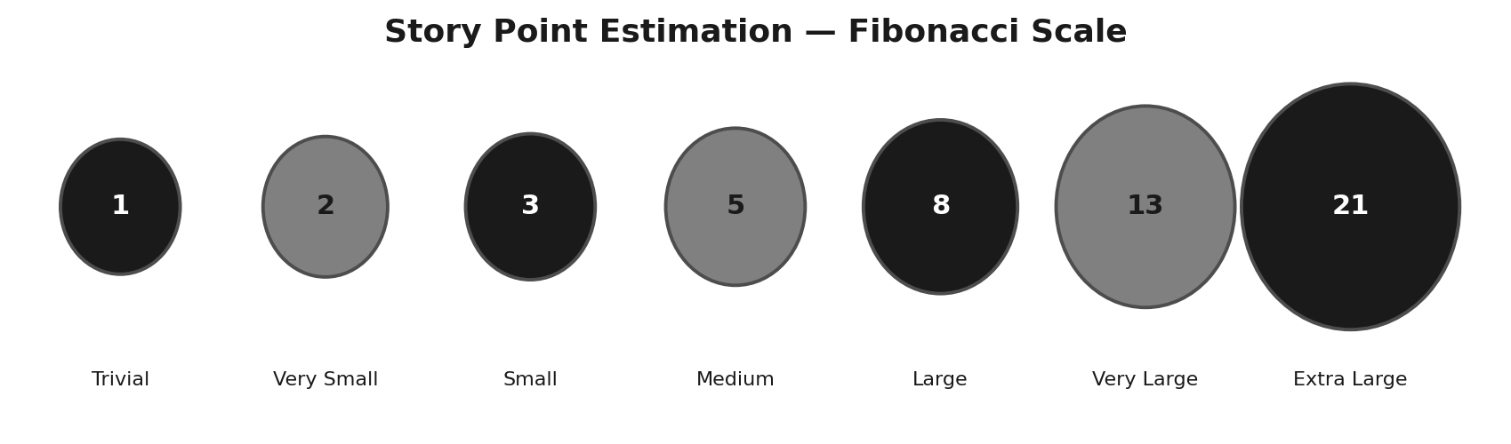
Figure 4: Fibonacci scale used for estimation
ID | User Story (Summary) | Points | Justification
US-1.1 | Forecast demand | 8 | Requires model design, data pipeline, and API work; moderate uncertainty in accuracy tuning.
US-1.2 | Forecasts by region/season | 5 | Builds on US-1.1 with added dimensional breakdown.
US-2.1 | Recommend stock allocation | 8 | Complex optimization logic combining multiple data sources.
US-2.2 | Stock level alerts | 3 | Rule-based thresholds; low complexity once allocation data exists.
US-3.1 | Supplier performance metrics | 5 | New data model plus dashboard visualisation.
US-3.2 | Automated purchase orders | 5 | Integration with supplier-facing workflow; moderate complexity.
US-4.1 | Real-time shipment tracking | 8 | Requires logistics-provider integration and live status updates.
US-4.2 | Shipment-arrival notifications | 2 | Simple event-driven notification once tracking exists.
US-5.1 | Monitor sales trends | 5 | Streaming data analysis with trend-detection thresholds.
US-6.1 | Automated reports | 8 | Aggregates data across all modules; deferred to a later sprint.

Sprint 1 committed capacity: US-1.1 (8) + US-2.1 (8) + US-2.2 (3) = 19 story points, judged achievable within a two-week sprint for the assigned team size.

7. Sprint Goal and Expected Deliverables

7.1 Sprint Goal
By the end of Sprint 1, deliver a working demand-forecasting and inventory-allocation module that produces reliable stock recommendations and flags under/overstocked items — establishing the data foundation that all later Epics (supplier coordination, shipment tracking, and reporting) will build upon.

7.2 Sprint 1 Deliverables
- A functioning demand-forecasting model exposed through an API.
- A store-wise inventory allocation recommendation engine.
- An alerting mechanism for under/overstocked items.
- A basic UI for viewing forecasts and allocation recommendations.

7.3 Expected Outcomes (Project-Level)
- Reduced stock shortages.
- Lower excess inventory.
- Improved supplier coordination.
- Faster replenishment cycles.
- Higher profitability.

7.4 Sprint 1 Board (Jira-style Snapshot)
Sprint execution is tracked on a Jira-style Scrum board with To Do, In Progress, and Done columns. Each card shows the user-story/task ID, a short description, the assigned story points, and the responsible role — giving the team a real-time, at-a-glance view of sprint progress.
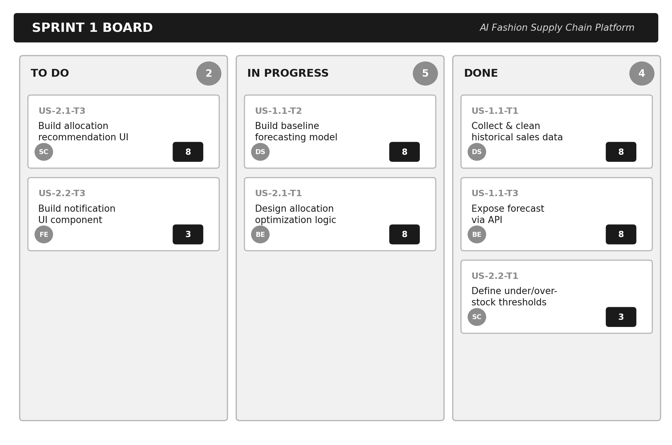
Figure 5: Illustrative Sprint 1 board tracking the committed user stories and tasks

Code of Conduct
I, D. Vyshali – 192411197 (Name / Reg No), certify that this submission is my original work and that I have adhered to the guidelines specified for this assessment. I understand that any violation of academic integrity rules will result in disciplinary action.
Signature of the student: D.vyshali
Date: 23/07/26

